**Assembly Instructions**

1. First of all some tools will be required in order to assembly the pump:
   1. Soldering iron, solder and wire.
   2. Hand saw (It will be needed to cut the Lead screw and the rail)
   3. Sand paper (It will be needed to sand down the sharp edges after cutting the Lead screw and the rail)
   4. Set of screw drivers
   5. Kapton/electrical tape
2. Laser cut the parts in the file [Manufacturing in 5 mm thickness Acrylic.ai](https://github.com/FrancisCrickInstitute/Four_channel_syringe_pump/blob/main/Manufacturing%20files/Mechanics/Adobe%20Illustrator/Manufacturing%20in%205%20mm%20thickness%20Acrylic.ai) which can be found on: <https://github.com/FrancisCrickInstitute/Four_channel_syringe_pump/tree/main/Manufacturing%20files/Mechanics/Adobe%20Illustrator> (Figure 1).

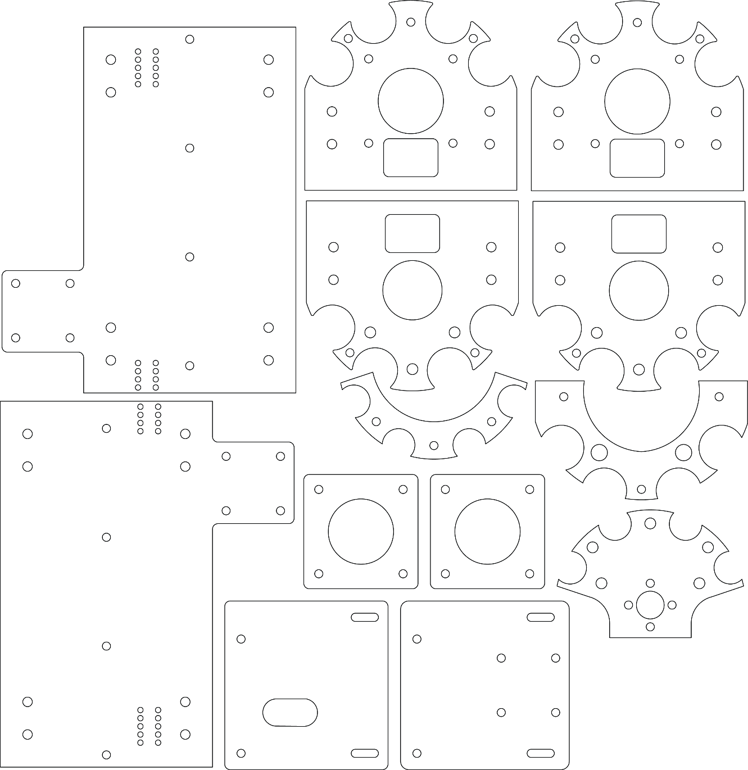

Figure 1: Parts to laser cut.

1. 3D print the parts (Knob.stl, Spacer.stl, Electronics spacer.stl and Nut holder.stl ) found on: <https://github.com/FrancisCrickInstitute/Four_channel_syringe_pump/tree/main/Manufacturing%20files/Mechanics/STL> (Figure 2).

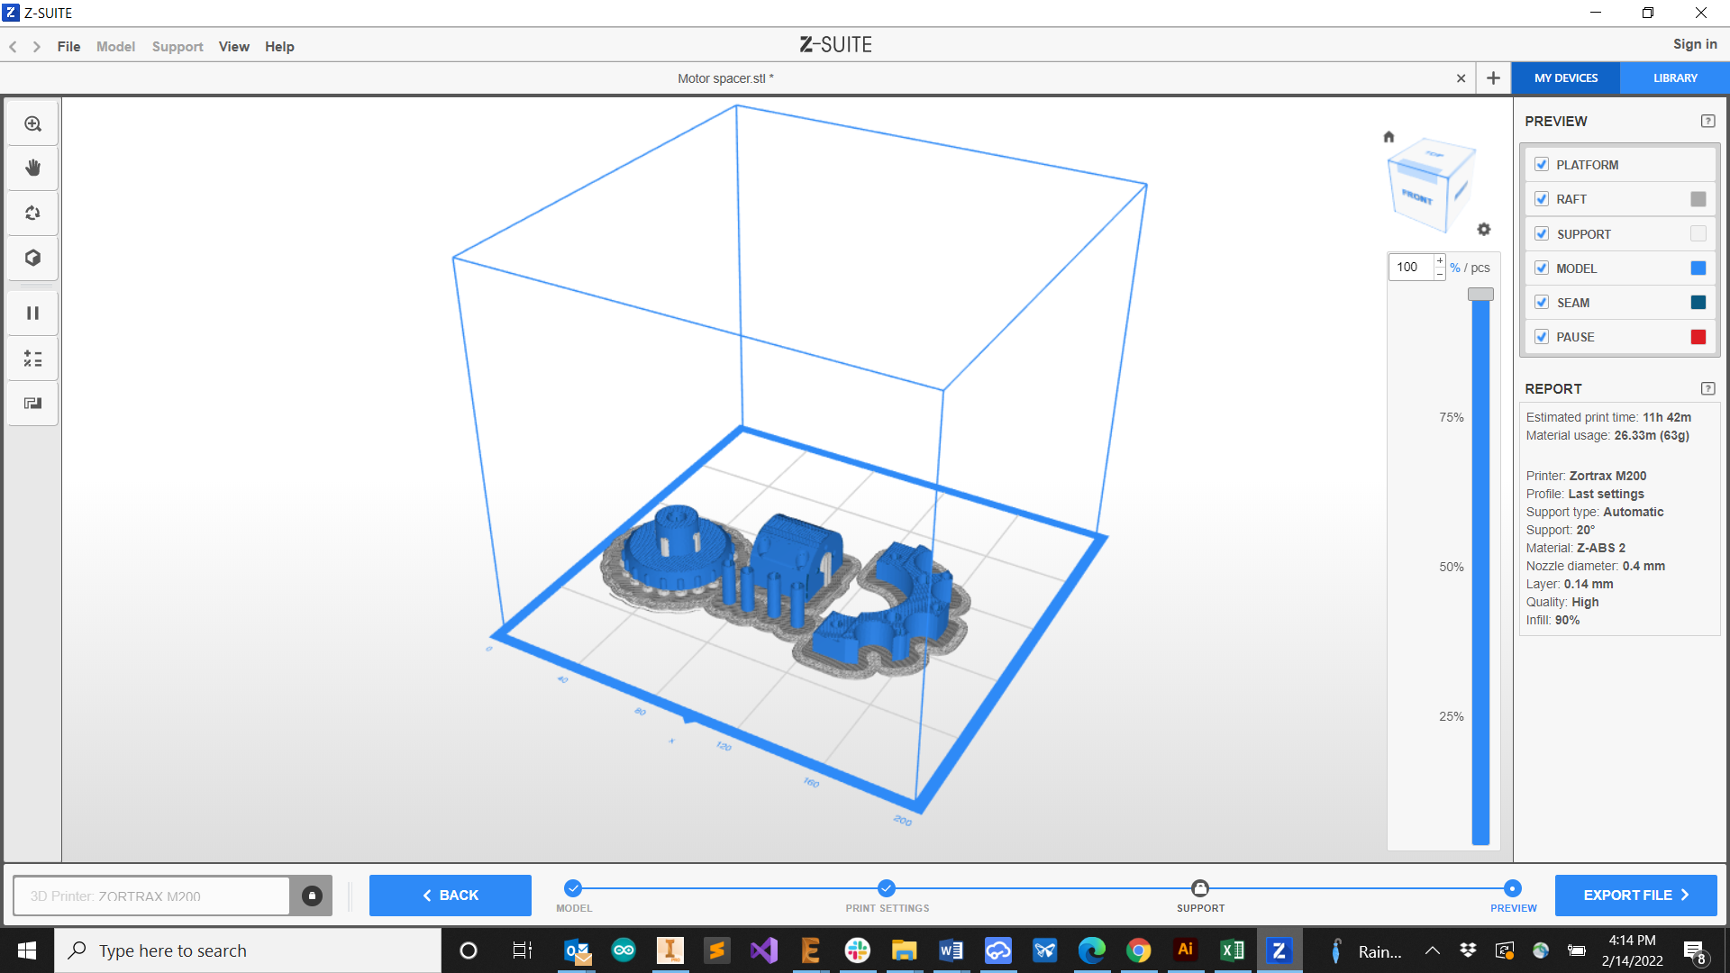

Figure 2: Parts to 3D print on the slicer simulation.

1. Order all the components needed for the pump assembly, they can be found in the bill of materials folder: <https://github.com/FrancisCrickInstitute/Four_channel_syringe_pump/tree/main/Bill%20of%20materials>
2. Cut the rail with a length of 134 mm and the lead screw a length of 170 mm using the metal handsaw.
3. Send the electronics to manufacture following the next steps:
   1. Go to **JLCBPCB**: <https://cart.jlcpcb.com/quote?orderType=1&stencilLayer=2&stencilWidth=100&stencilLength=100>
   2. Upload the Gerber files (Figure 3):

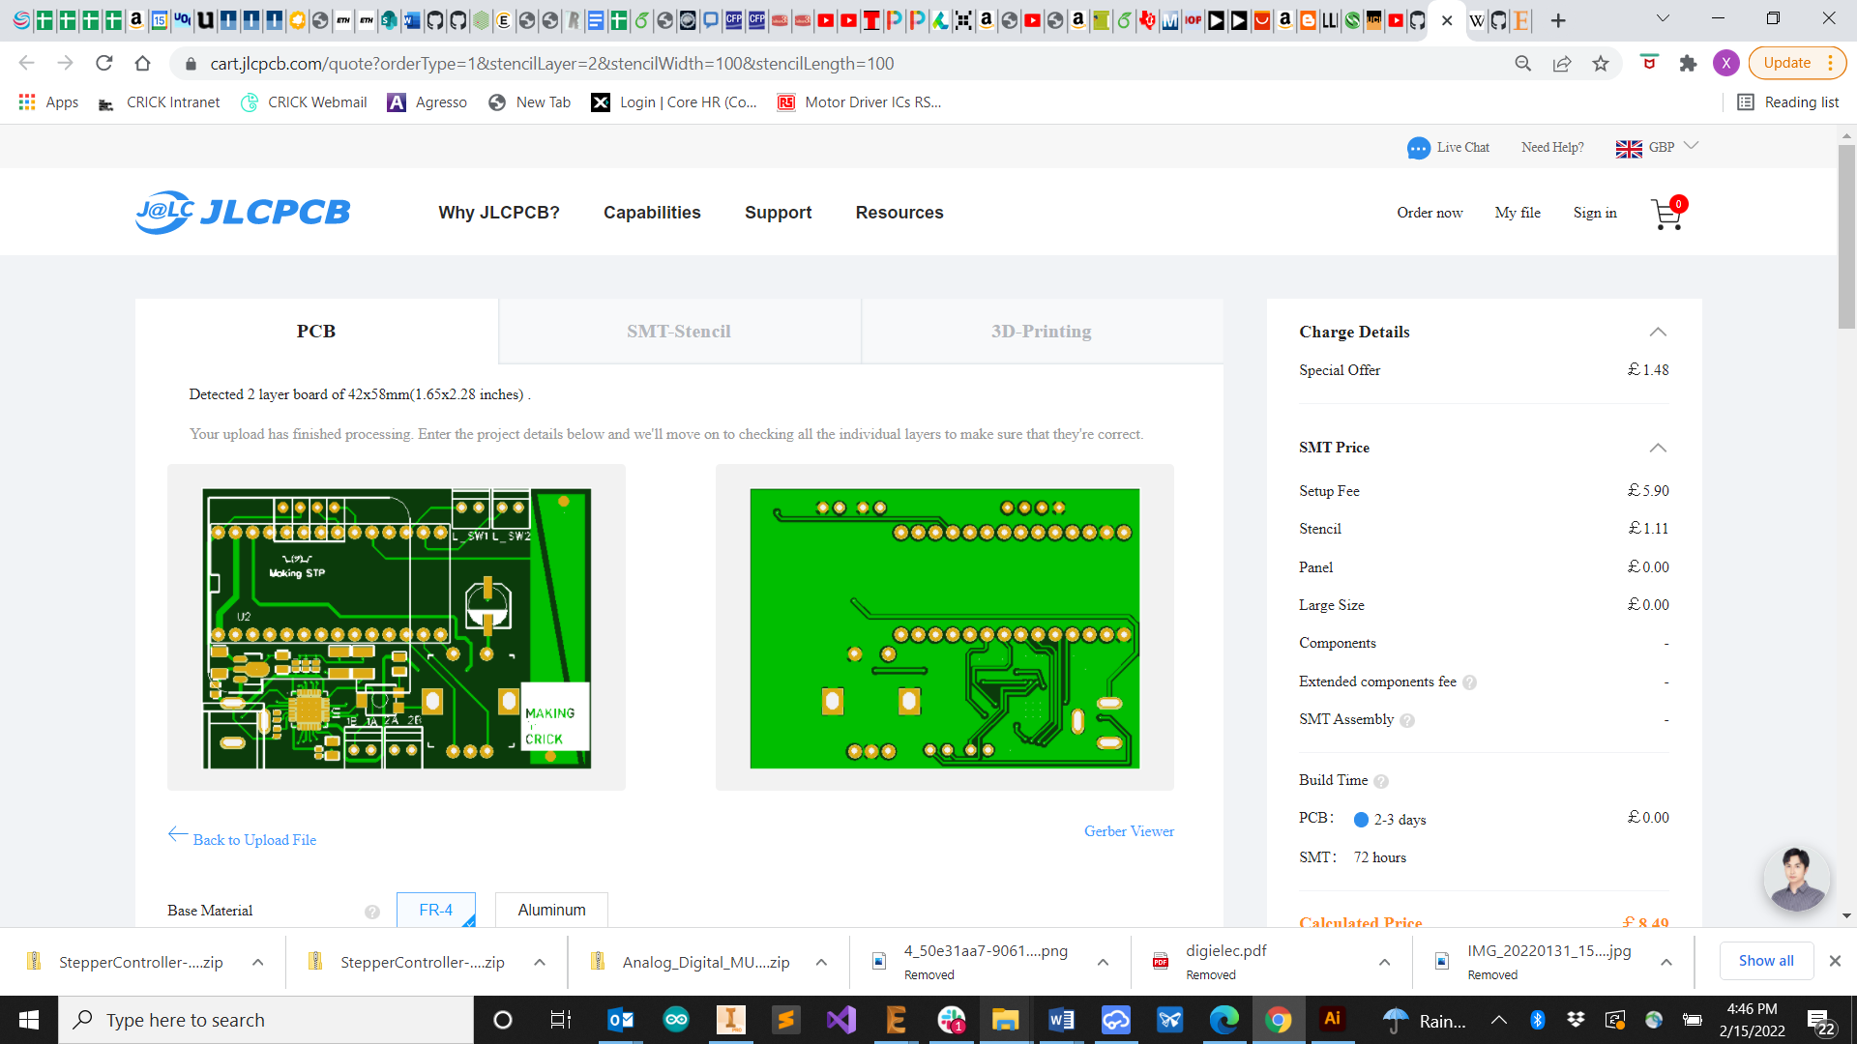

Figure 3: Gerber upload.

* 1. Scroll down on the same page and Select **SMT Assembly** (Figure 4)**.**

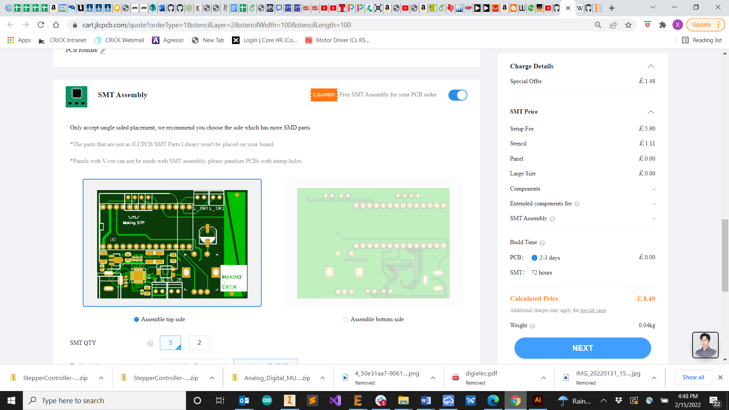

Figure 4: SMT selection.

* 1. Upload the **BOM** file and **pick and place** files which you will find inside the folder (Figure 5): <https://github.com/FrancisCrickInstitute/Four_channel_syringe_pump/tree/main/Manufacturing%20files/Electronics/Bill%20of%20materials%20and%20Pick%20and%20place>

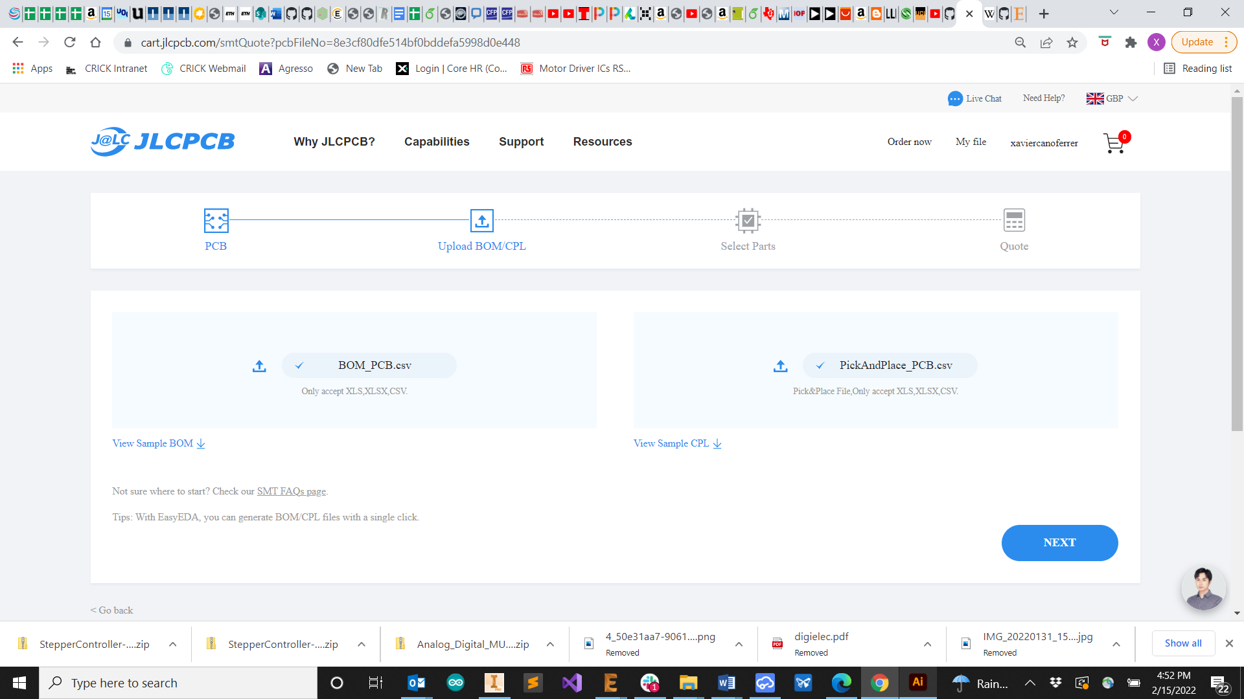

Figure 5: BOM and Pick and place upload.

* 1. Click next and leave selected all parts available (Figure 6):

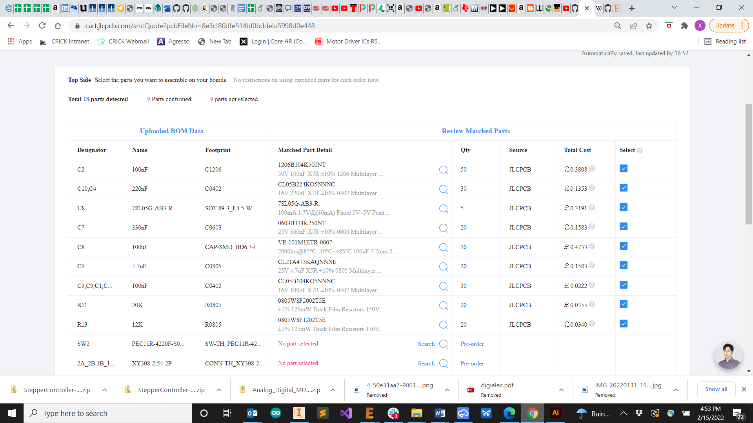

Figure 6: BOM and Pick and place upload.

1. Click save to card (Here you will be able to see all the parts they have in stock and which can be populated) It could happen that some parts are not currently in stock in that case we suggest to buy them and solder them manually after the parts are received (Figure 7):

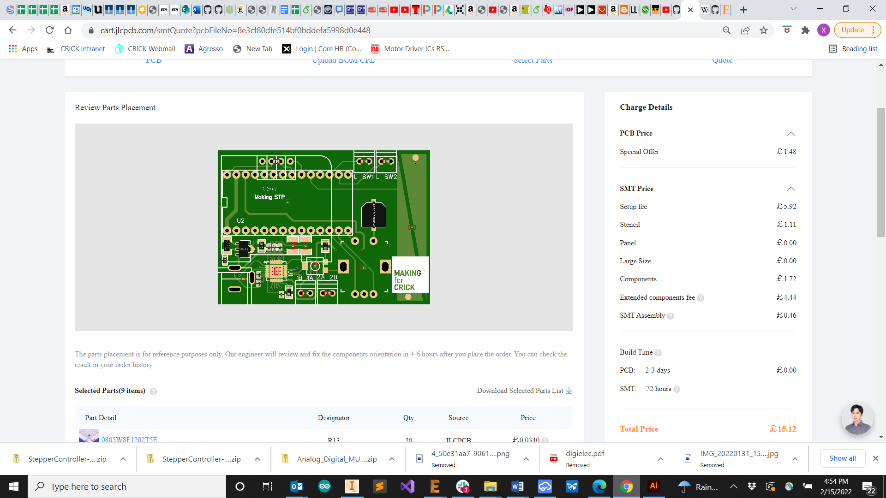

Figure 7: BOM and Pick and place upload.

1. Solder the missing surface mounted parts such as the 10k potentiometer on the PCB, the rotary encoder and the screw terminals (Figure 8a).
2. Solder the Teensy 3.2 on the PCB (Figure 8b).
3. Add Kapton or electrical tape on the back of the OLED display (Figure 8c).
4. Solder the OLED display (Figure 8d).
5. Solder 10 mm wires to the limit switches (Figure 8e).

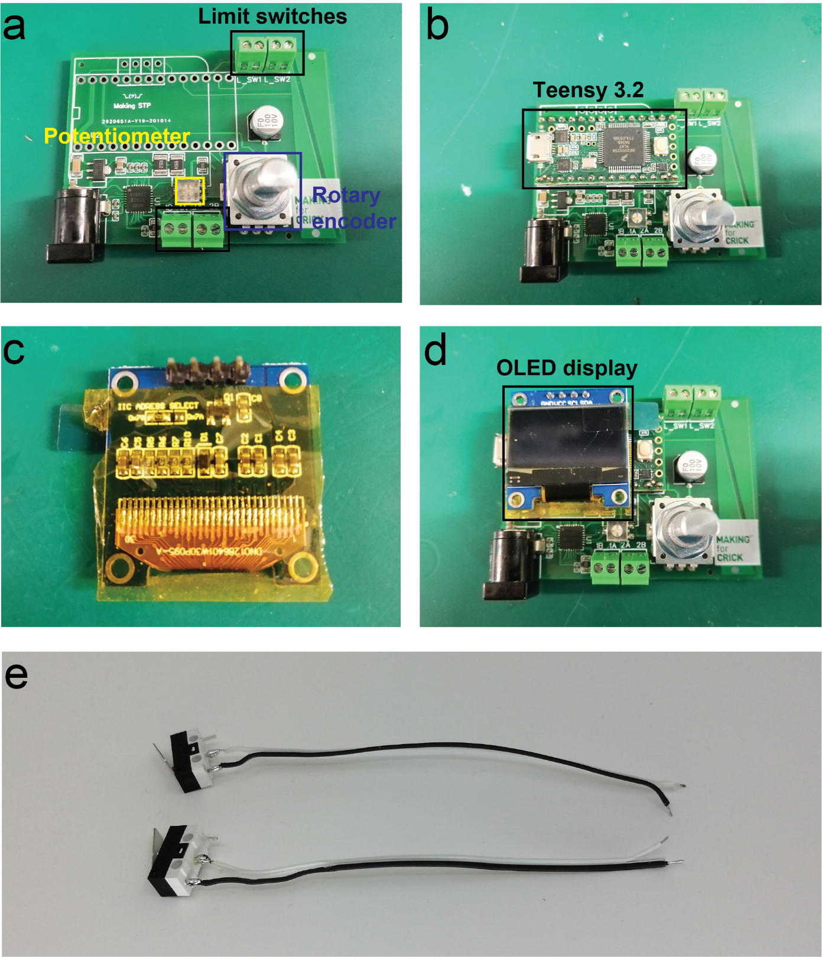

Figure 8: Electronics assembly.

At this point after ordering all the components you should have all the components present in Figure 9 ready:

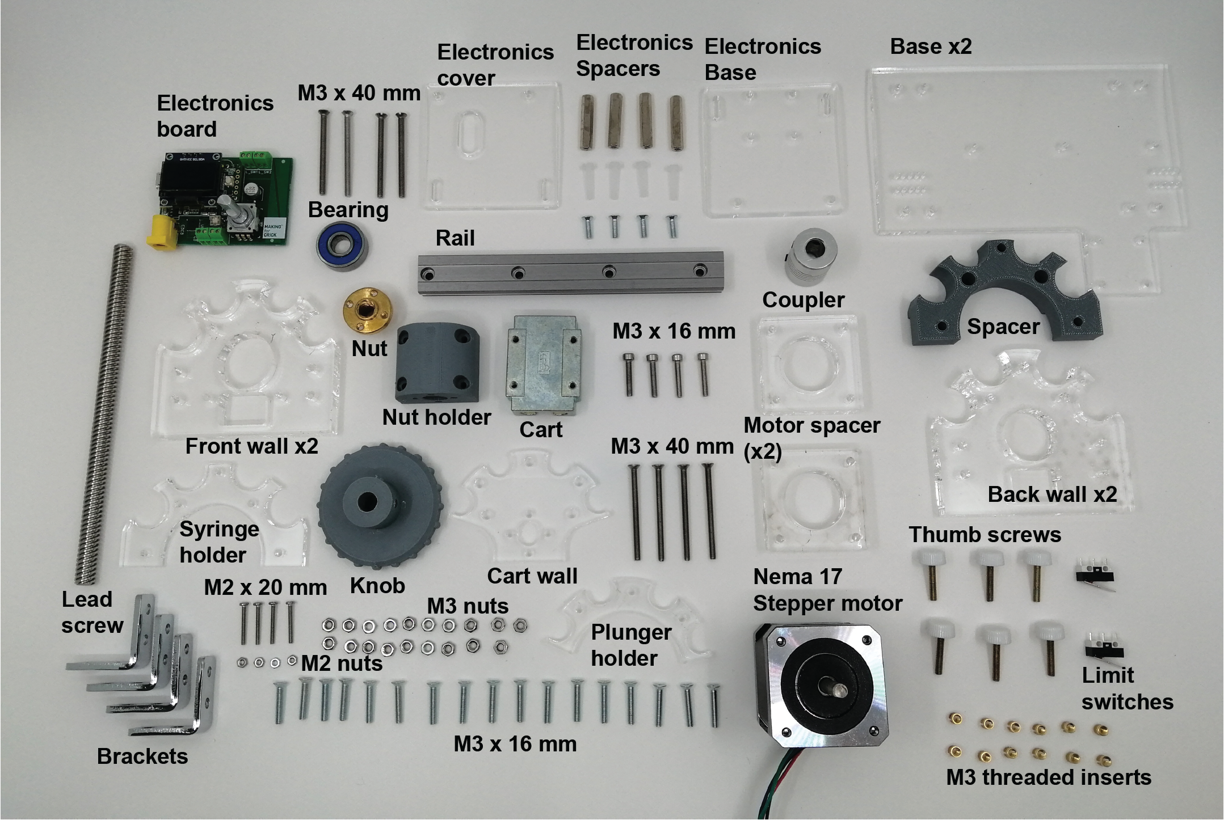

Figure 9: Components for the assembly.

1. Insert the M3 brass threaded inserts inside the knob, spacer, cart wall and electronics spacer by applying heat with the soldering iron (Figures 10a-d). An example video of the process: <https://www.youtube.com/watch?v=x2SYHr0kyTE> .

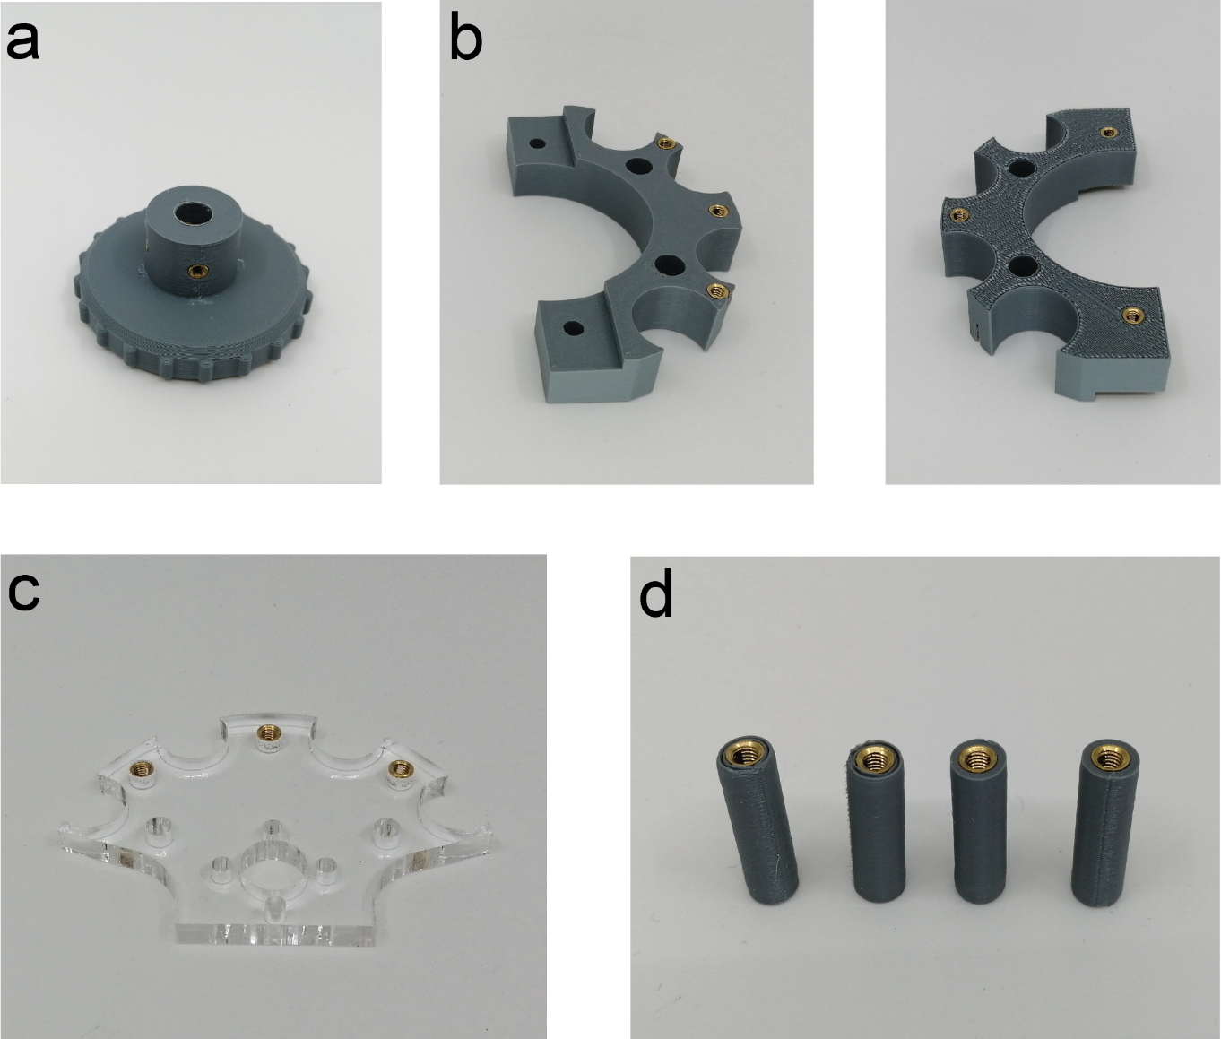

Figure 10: Threaded inserts assembly.

1. Attach the 3D printed part nut holder with the cart (Figure 11a).
2. Then use four 40 mm long M3 screws to attach the cart wall with the nut and the nut holder (Figure 11b).
3. The bearing is attached to the back wall just by applying pressure and both walls are assembled with the brackets using M3 screws (Figure 11c).
4. Then assemble the plunger holder with the cart wall using the M3 thumb screws (Figure 11d).
5. Attach the base and the rail with four M3 screws (Figure 11e).
6. Couple the coupler with the stepper motor shaft, there are two grub screws to tighten and secure the connection (Figure 11f).
7. Insert a couple of screws to the knob treads (Figure 11g).
8. Attach the stepper motor with the front wall (Figure 11h).
9. Couple the 8mm lead screw with the coupler using an Allen key (Figure 11i).

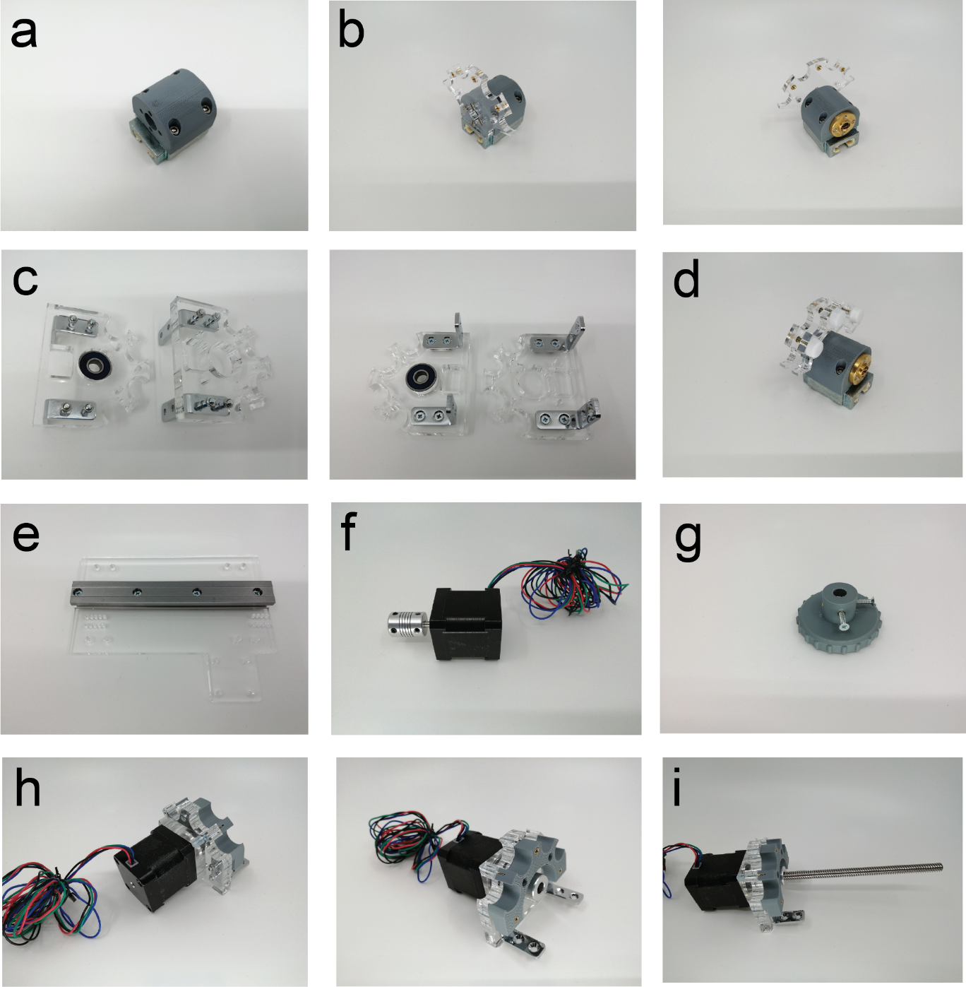

Figure 11: Assembly steps 1.

1. Attach the base with the motor assembly with M3 screws and nuts (Figure 12a).
2. Now slide the cart through the rail with the brass nut facing the open side and attach the back limit switch with M2 screws and nuts (Figure 12b).
3. Attach the back wall making the lead screw pas through the bearing hole and using again M3 screws and nuts to assemble the brackets (Figure 12c).
4. Attach the electronics base and connect the limit switch and motor wires with the screw terminals (Figure 12d). Make sure the motor wires that have low resistance with each other are connected in contiguous connectors. Add some electric tape on the PCB bottom to avoid contact with metal screws, another option is to use nylon M3 screws.
5. Finish the electronics cover assembly with the electronics spacers also using M3 screws (Figure 12e). And attach the second base below the motor cables confining those in between the two layers.

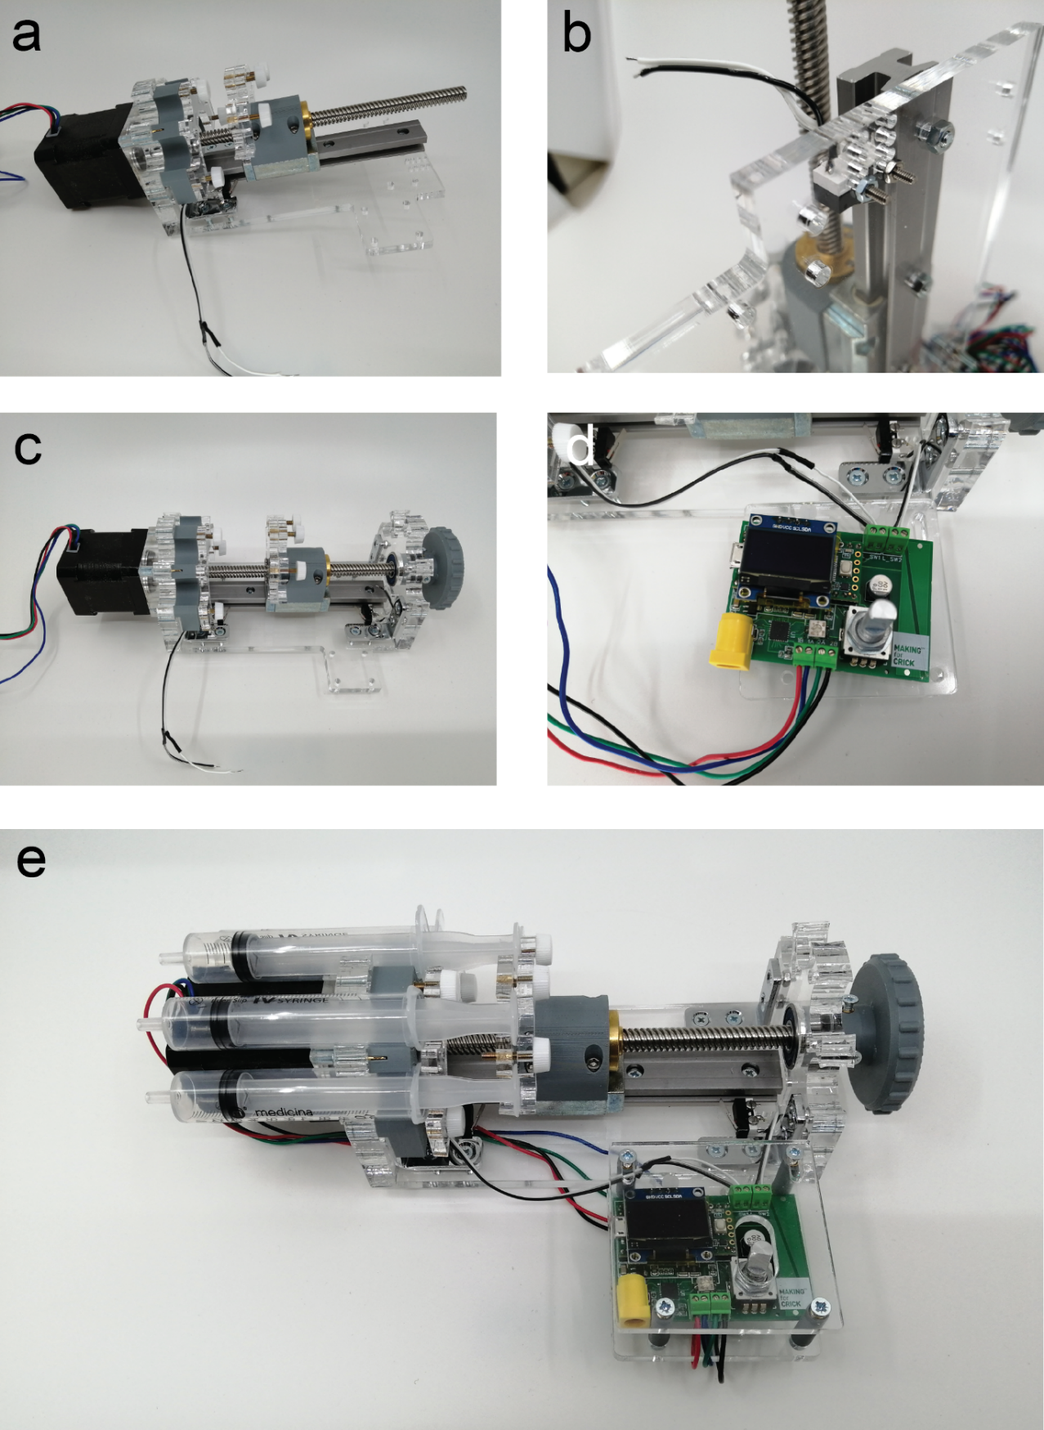

Figure 12: Assembly steps 2.

1. Cut the stepper motor and limit switch cables at the shortest length and connect them to the screw terminals.
2. Download the Arduino IDE on the website: <https://www.arduino.cc/en/software>
3. Download the Teensyduino on the website: <https://www.pjrc.com/teensy/teensyduino.html>
4. Open the Arduino IDE
5. Select the Board Teensy 3.2 in Tools/Board/ “Teensy 3.1/3.2”
6. For Windows computers: Select the COM port in Tools/Port/ “COM#(Teensy 3.2)”
7. Upload the code [MSTPump_Contstant_flow.ino](https://github.com/FrancisCrickInstitute/Four_channel_syringe_pump/blob/main/Firmware/MSTPump_Contstant_flow/MSTPump_Contstant_flow.ino) which can be found on: <https://github.com/FrancisCrickInstitute/Four_channel_syringe_pump/tree/main/Firmware/MSTPump_Contstant_flow>
8. Connect the pump to the power supply through the barrel jack connector.
9. Select the flow rate desired and press the rotary encoder push button, it will enable the power on the motor driver and the pump will start dispensing at the selected flow reate.
10. The volume dispensed is also displayed live on the OLED screen.